RUNGTA COLLEGE OF ENGINEERING & TECHNOLOGY

TECHNICAL TRAINING PROJECT (CYBER SECURITY)

Name of Project:
Comparative Security Analysis of Telnet and SSH Using
Network Traffic Capture

Branch: CSE (CORE) – 3rd Semester
Section: B
Student Name : ABHISHEK BAG YADAV
ERP ID: 6606929
Professor Name: Prashant Kamkar
Date of Submission: 26-12-25

Student Signature: ____________________
Professor Signature: ____________________

1.Introduction
With the rapid growth of computer networks and internet-based services, secure remote communication has become an essential requirement in modern computing systems. Remote login protocols allow users to access and manage systems from distant locations. Among these protocols, Telnet and SSH (Secure Shell) are commonly used for remote system access.
Telnet is one of the earliest remote access protocols and was widely used in the initial stages of network development. However, Telnet transmits all data, including usernames, passwords, and commands, in plain text, making it highly vulnerable to network attacks such as packet sniffing and man-in-the-middle attacks. Due to these security weaknesses, Telnet is now considered insecure and deprecated.
SSH was introduced as a secure alternative to Telnet. It uses strong encryption techniques to protect data during transmission, ensuring confidentiality, integrity, and authentication. As a result, SSH has become the industry-standard protocol for secure remote access in modern networks.
This project focuses on a comparative security analysis of Telnet and SSH using network traffic capture. By capturing and analysing network packets with the help of Wireshark, the project practically demonstrates how Telnet exposes sensitive information in plain text, while SSH keeps communication encrypted. This hands-on approach helps in understanding the importance of encryption and secure communication in cyber security.

2. Project Overview (Detailed Explanation)

Purpose of the Project
The primary aim of this project is to compare the security of Telnet and SSH by observing how they transmit data over a network. Telnet is an older protocol that sends data in plain text, which makes it vulnerable to attacks like packet sniffing and man-in-the-middle (MITM) attacks. SSH, on the other hand, is a modern, secure protocol that encrypts all transmitted data, ensuring that sensitive information cannot be read by attackers.
This project gives practical evidence to help students understand the importance of encryption in network security.

Lab Setup
To perform this project, a virtualized lab environment is used:
- Server Machine
  - Operating System: Kali Linux
  - Role: Hosts both Telnet and SSH services.
  - Purpose: Provides a target system for remote login.
- Client / Attacker Machine
  - Operating System: Windows / Linux / macOS
  - Role: Acts as the user logging into the server and as an attacker capturing traffic.
  - Tools: Wireshark is installed to capture network packets.
- Virtual Network
  - Both machines are connected on the same network (host-only or bridged in VirtualBox/VMware).
  - This setup ensures that all traffic between the client and server can be captured and analysed.

3. Objectives
The main objectives of this project are:
- To configure and run Telnet service on Kali Linux
- To capture Telnet traffic using Wireshark
- To observe plain-text usernames, passwords, and commands
- To configure and run SSH service
- To capture SSH traffic and analyse encrypted packets
- To perform a comparative security analysis of Telnet and SSH
- To simulate a real-world attacker scenario using packet sniffing

4. Tools and Technologies Used
- Operating System: Kali Linux
- Protocols: Telnet, SSH
- Services:
  - Telnet (in.telnetd)
  - OpenSSH (sshd)
- Packet Capture Tool: Wireshark
- Virtualization Tool: VirtualBox / VMware

telnet
Telnet is one of the earliest protocols developed for remote access to computers. It enables a user to connect from one system to another over a network and operate the remote system as if they were physically present at that machine. During a Telnet session, the client and the server continuously exchange data in the form of keyboard inputs and command outputs.
Telnet was designed in an era when network security was not a primary concern. As a result, the protocol does not provide any form of encryption or data protection. All information transmitted during a Telnet session, including login credentials and executed commands, is sent across the network as plain ASCII text.
Due to the absence of encryption, Telnet communication is highly vulnerable to packet sniffing attacks. Any attacker who has access to the same network can use a packet capture tool to monitor the traffic and easily read usernames, passwords, and command outputs in a human-readable format. Because of these serious security weaknesses, Telnet is now considered unsafe and has largely been replaced by more secure protocols such as SSH.
In modern network environments, Telnet is rarely used for real-world communication. It is mainly retained for legacy system support, testing purposes, or educational demonstrations, where the objective is to observe and understand how insecure network protocols transmit data.

(1) Installing and enabling Telnet on Kali
First, the package list on Kali was updated so that the latest software versions were
available. Then, the Telnet daemon and the inetd service were installed to provide
Telnet server functionality. The inetd service acts as a super‑server that listens for
incoming connections and starts the Telnet daemon when required.
>>>>update package list:
Command executed:

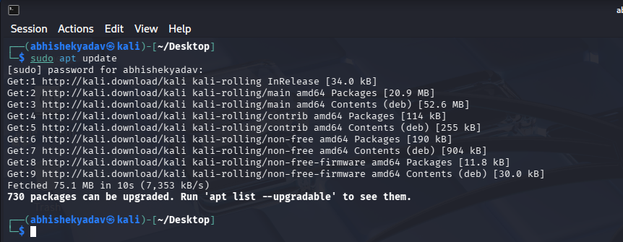

>>>>install Telnet server and inted : Command executed:
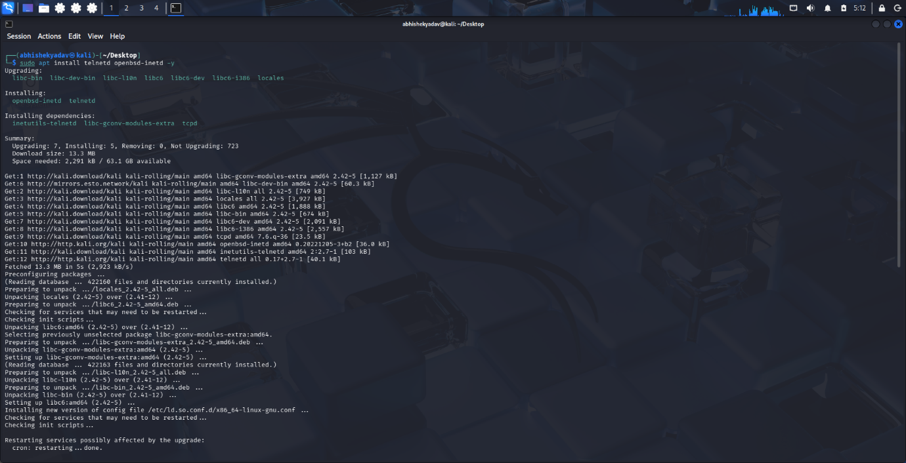
>>>> start and enable inted: Command executed:
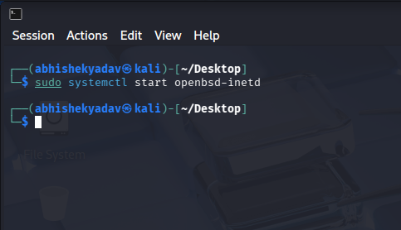
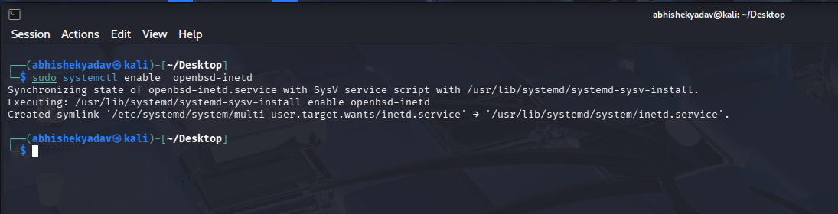

>>>>Check status: Command executed:
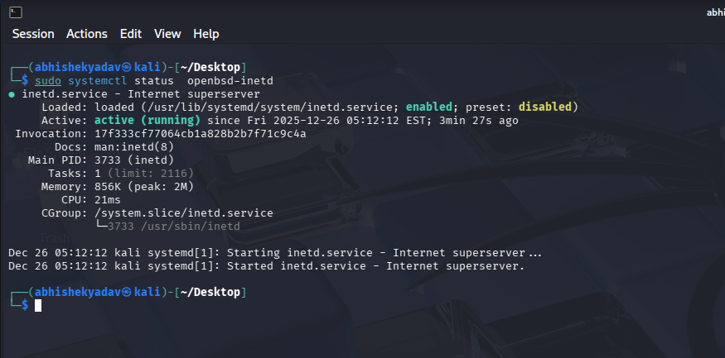
>>>>Telnet configuration(TELNET testing localhost): Command executed:
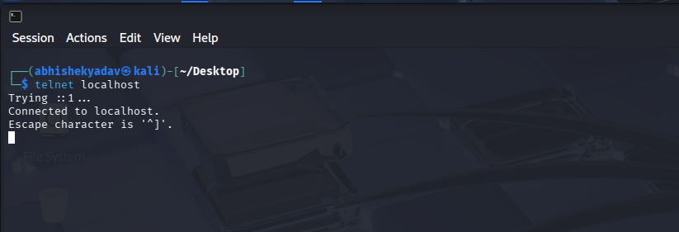
>>>>Discovering the server ip address: Command executed:
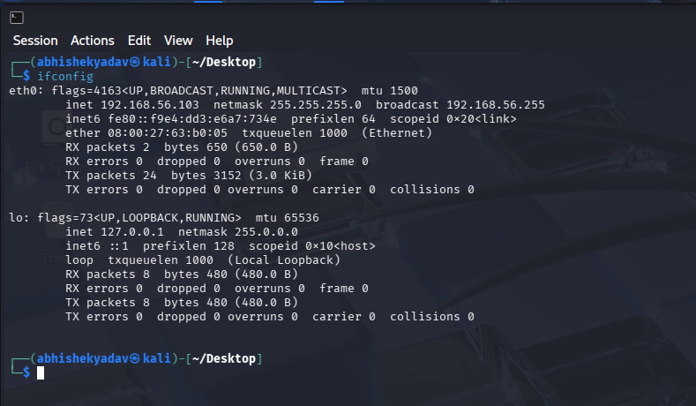

>>>>Establishing a Telnet Connection from the Client:
The Telnet client on the user machine was used to connect to the Kali Linux server using its IP address. In this setup, the client machine represented the remote user system, while the Kali Linux machine acted as the Telnet server. By executing the command telnet <KALI_IP>, the client successfully established a connection with the Telnet service on the Kali machine, and the remote login prompt was displayed on the client terminal.
Command executed over telnet
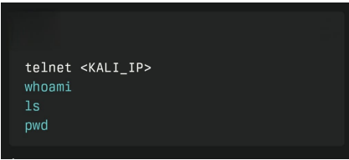

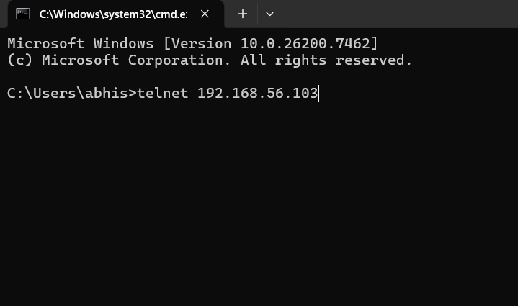

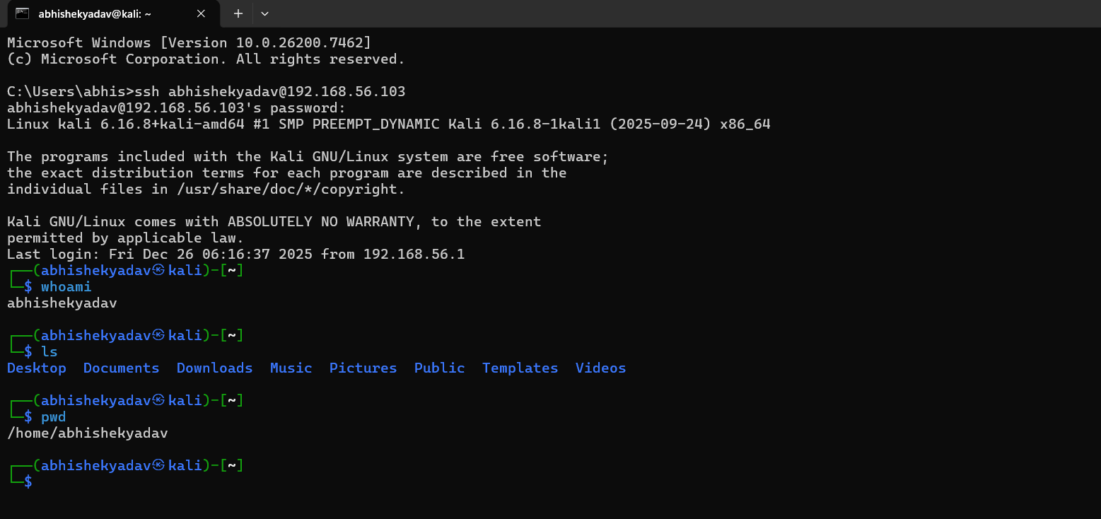
>>>>Analysing Telnet traffic in Wireshark
In this step, the Telnet traffic generated in the previous section is analysed using Wireshark. After stopping the capture, one Telnet packet from the session is selected and the TCP stream is followed. The stream window clearly shows the username, password and all commands in readable plain text. This demonstrates that Telnet does not provide any encryption and that an attacker who captures the traffic can easily see the login credentials and command history.
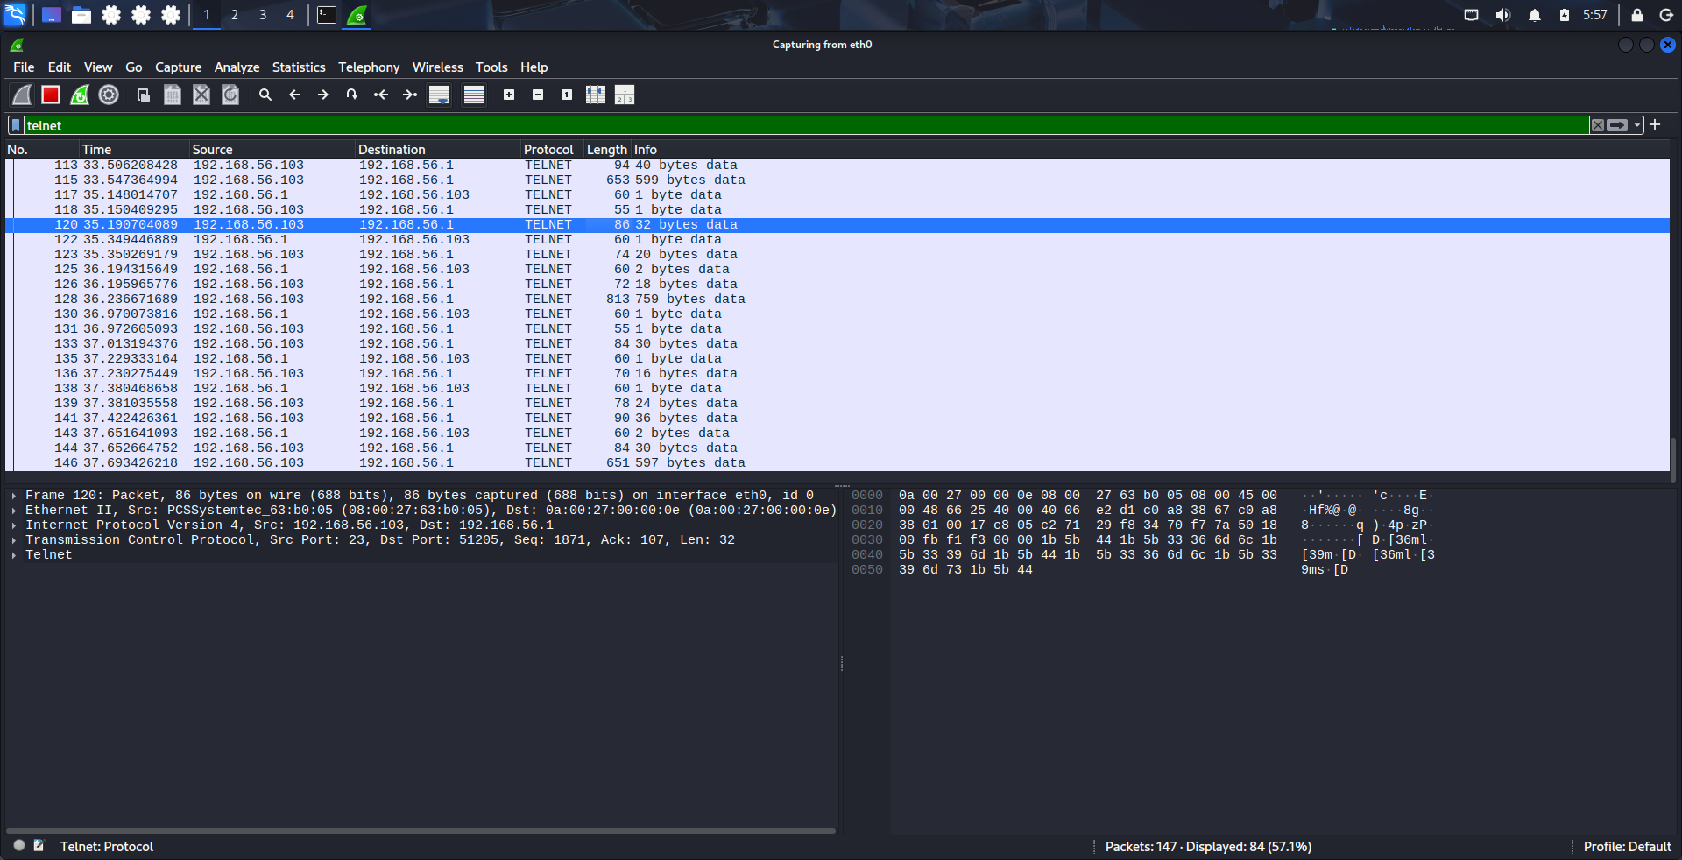

HERE LOGIN USERNAME AND PASSWD IN PLAIN TEXT
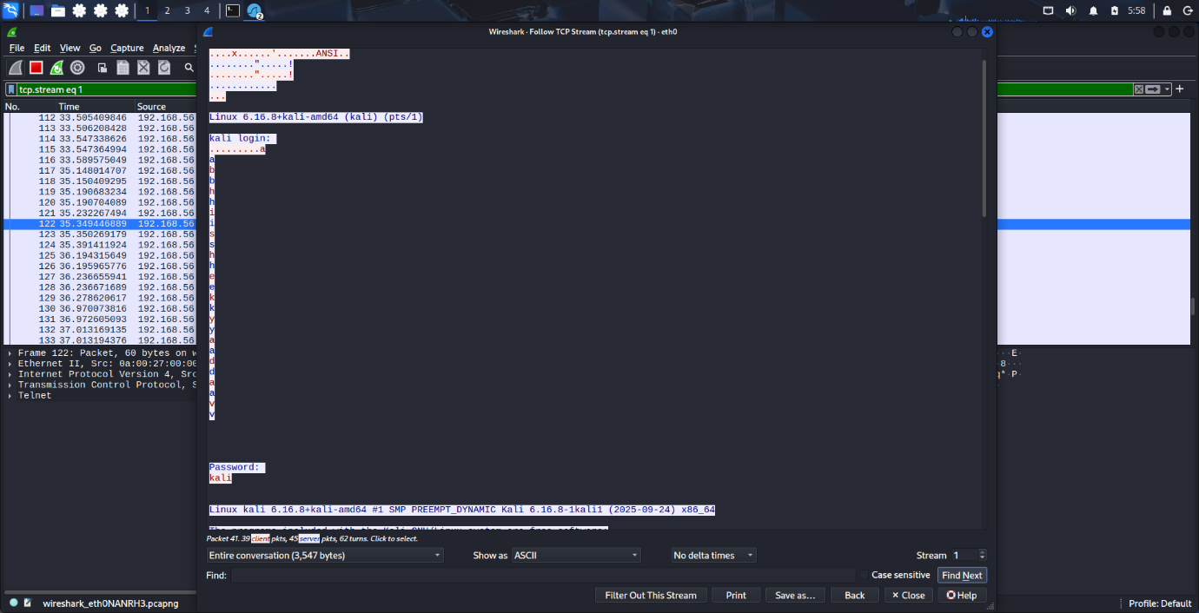

SSH

SSH (Secure Shell) is a cryptographic network protocol that provides secure
remote access to computers and servers over an unsecured network. It was
developed as a secure replacement for insecure protocols like Telnet and rlogin,
which transmit data including usernames, passwords, and commands in plaintext,
making them vulnerable to eavesdropping attacks.
What SSH DoesSSH
establishes a secure channel between a client (your computer) and a server
(remote machine) using strong encryption algorithms. All communication—login
credentials, file transfers, port forwarding, and command execution—travels
encrypted through this tunnel, protecting against packet sniffing, man-in-themiddle attacks, and unauthorised interception.
Core Components of SSH
SSH Client: Software on your local machine (like OpenSSH client on Linux/
Windows) that initiates connections.
SSH Server (sshd): Daemon running on the remote machine listening on TCP port
22, handling incoming connections.
Encryption: Uses symmetric ciphers (AES-256) for bulk data, asymmetric (RSA/
ECDSA) for key exchange and authentication.
Authentication Methods: Password-based, public-key (preferred), host-based, or
multi-factor.
>>>>INSTALL SSH SERVICE: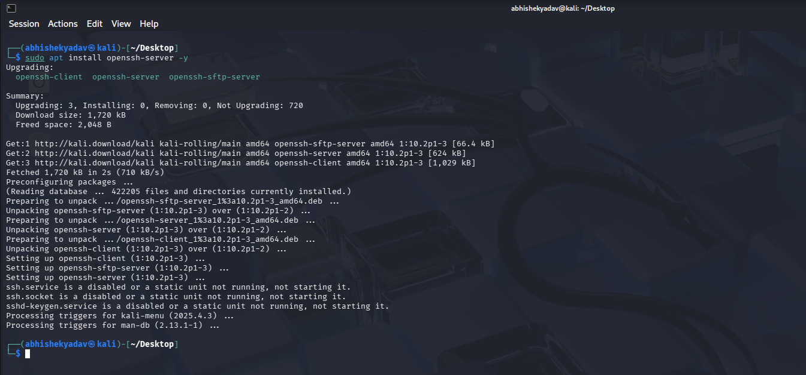
>>>START AND ENABLE SSH SERVICES:

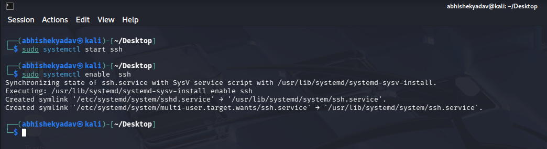
>>>STATUS OF SSH SERVICES
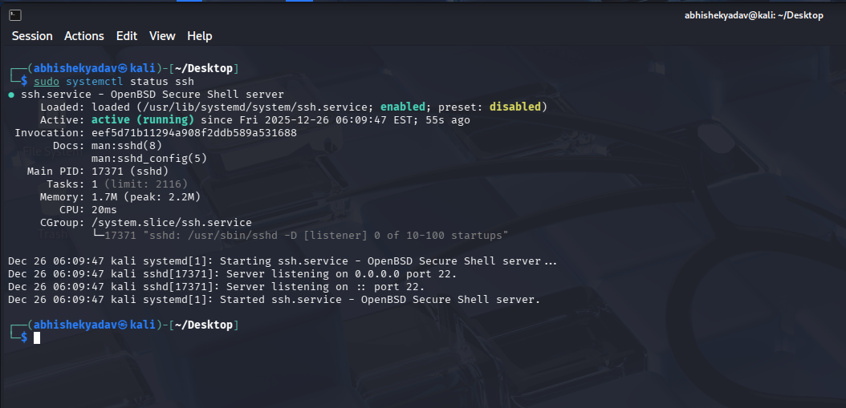
>>> SSH COMMAND EXCUTE IN <KALI IP>
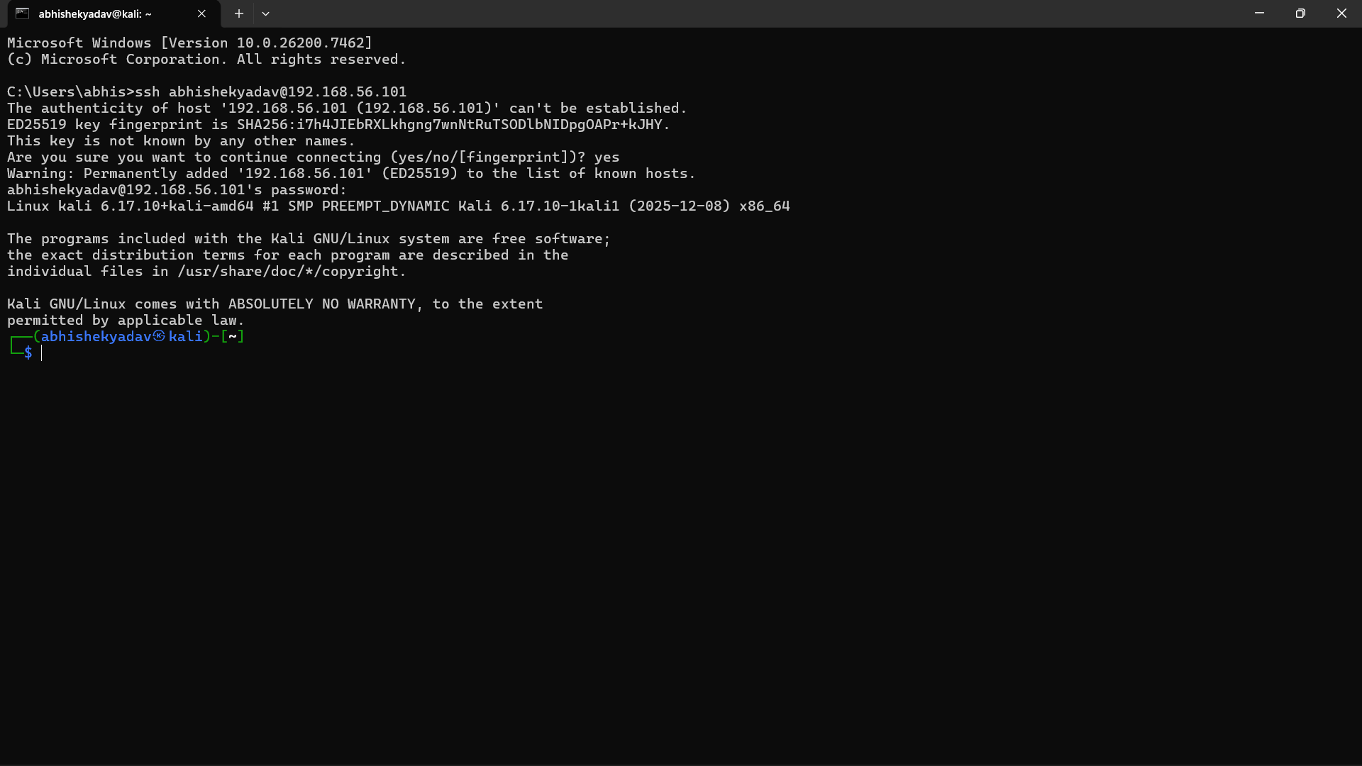

>>> COMMAND EXCUTE FOR INPUTS
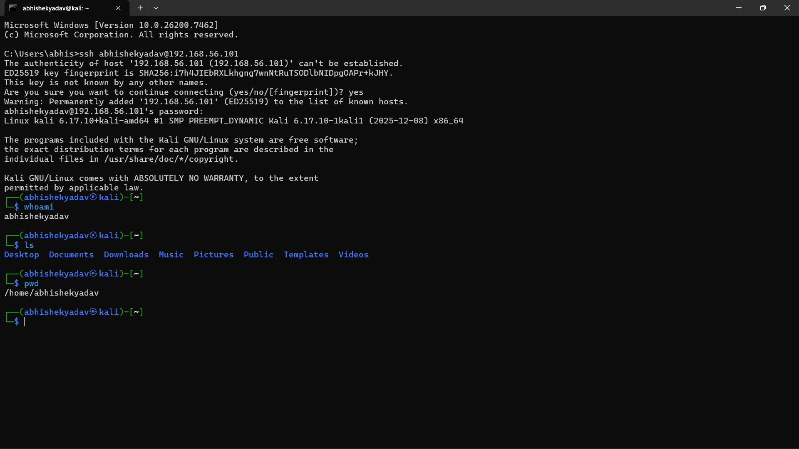
>>>>Capturing SSH Traffic in Wireshark:
Wireshark was started on the client machine to capture network traffic on the active interface during the SSH connection. The capture began before executing the SSH command and continued through login and command execution to record the complete session
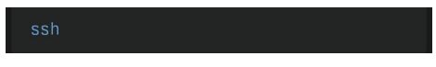
Alternative filter: Analysis performed: Right-click packet → Follow → TCP Stream Result: Random unreadable bytes (encrypted payload)

>>>SSH TRAFFIC COMMANDS:

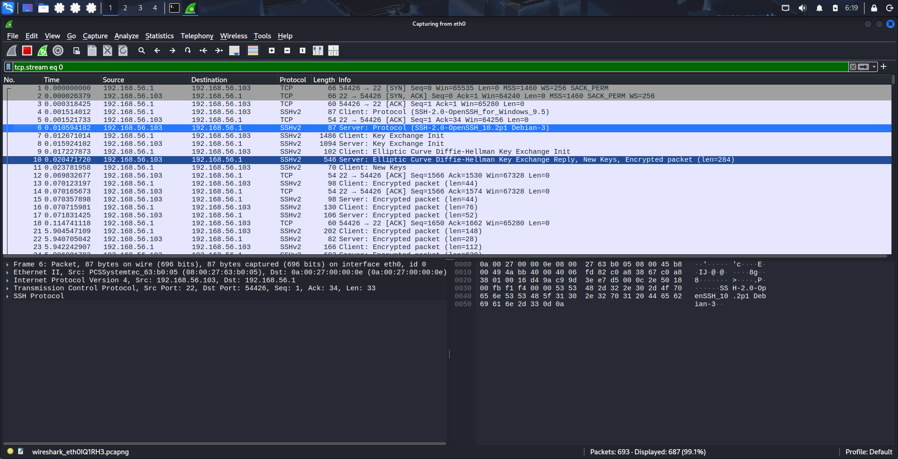

>>>SSH PACKETS IN ENCRYPTED FORM :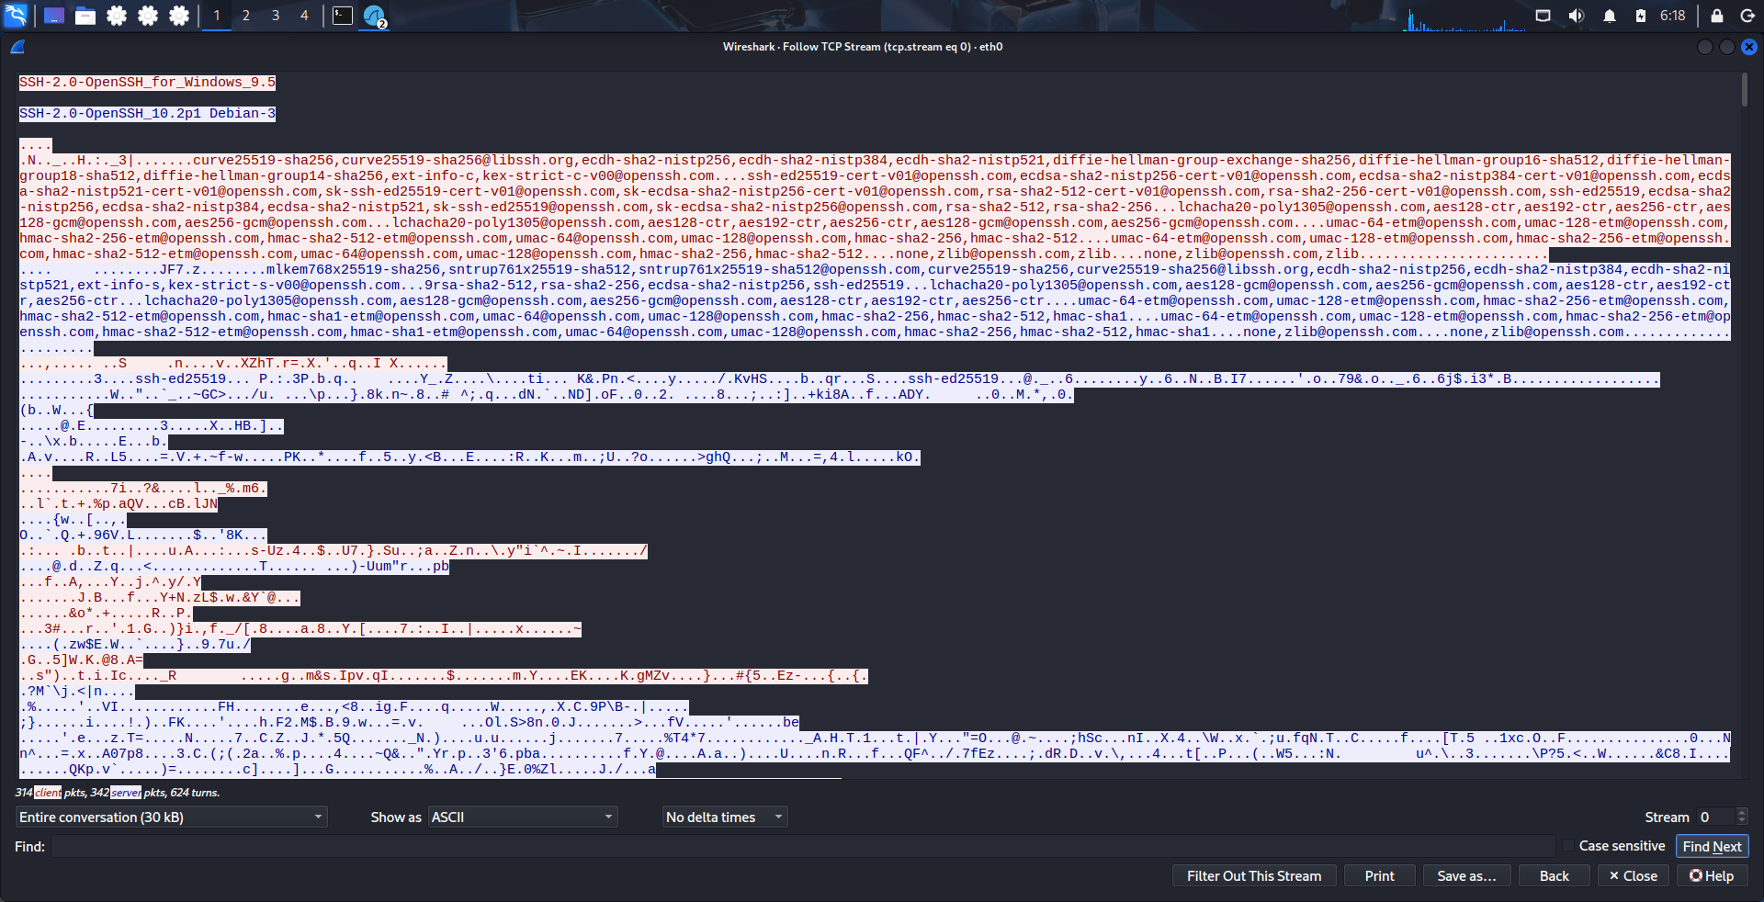
Comparative Analysis: Telnet vs SSH Both protocols enable remote command-line access but differ fundamentally in security implementation. Telnet transmits all data unencrypted while SSH provides comprehensive cryptographic protection . why telnet is insecure and deprecated.

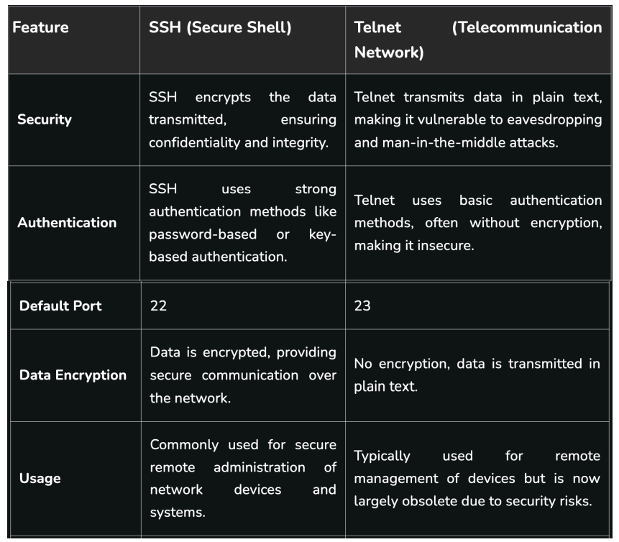

Why Telnet Is Insecure and No Longer Used
Telnet is now considered unsafe and is mostly not used because it does not provide proper security.
1. Data Is Sent in Plain Text
The biggest problem with Telnet is that it sends all information in plain text.
This means usernames, passwords, and commands are sent without any protection.
If someone is monitoring the network using tools like Wireshark, they can easily see this information.
2. Easy to Spy on Connections
Since there is no encryption, attackers can quietly watch Telnet sessions.
They can read what the user types and what the server replies, without being noticed.
3. Man-in-the-Middle Attacks
In Telnet, an attacker can place themselves between the user and the server.
They can see, change, or add data during the communication, and both sides remain unaware.
4. Weak Login Security
Telnet only uses basic username and password login.
These details are sent openly on the network and there is no support for strong security methods like encryption keys.
5. Old Technology
Telnet was created in 1969, when networks were small and trusted.
At that time, security threats were very limited, which is why strong protection was not included.
6. Replaced by SSH
Telnet is no longer recommended because SSH (Secure Shell) is available.
SSH protects all data by encrypting it and provides secure login methods.

How Network Sniffing Attacks Work
Network sniffing is an attack where hackers capture and read data moving through a network using special software.
Step-by-Step Explanation
1. Data Travels as Packets
Whenever data is sent on a network, it is broken into small parts called packets.
Each packet contains sender and receiver details along with the data.
2. Attacker Position
The attacker places a system with sniffing software in a location where it can see network traffic.
- Passive Sniffing
On networks like hubs or Wi-Fi, all devices can see all traffic.
The attacker simply listens without changing anything.
- Active Sniffing
On switched networks, attackers use methods like ARP spoofing to trick devices into sending data to the attacker first.
3. Capturing Packets
The attacker sets the network card to promiscuous mode, which allows it to capture all packets.
Tools like Wireshark or tcpdump are used for this purpose.
4. Reading the Data
If the captured traffic is not encrypted (such as Telnet or HTTP), the attacker can easily read usernames, passwords, and messages.

Why SSH Is the Standard Secure Remote Login Protocol
SSH is widely used today because it provides strong security and is easy to use for remote access.
1. Built for Security 🔐
SSH was designed to solve the security problems of older protocols like Telnet.
It provides:
- Encrypted communication
- Protection against data changes
- Verification of the server’s identity
- Secure login options
This makes SSH safe even on public or unsafe networks.
2. Secure Key-Based Login
SSH allows login using public and private keys, which is safer than passwords. Why Telnet Is Insecure and No Longer Used

Telnet is now considered unsafe and is mostly not used because it does not provide proper security.

1. Data Is Sent in Plain Text

The biggest problem with Telnet is that it sends all information in plain text.
This means usernames, passwords, and commands are sent without any protection.
If someone is monitoring the network using tools like Wireshark, they can easily see this information.

2. Easy to Spy on Connections

Since there is no encryption, attackers can quietly watch Telnet sessions.
They can read what the user types and what the server replies, without being noticed.

3. Man-in-the-Middle Attacks

In Telnet, an attacker can place themselves between the user and the server.
They can see, change, or add data during the communication, and both sides remain unaware.

4. Weak Login Security

Telnet only uses basic username and password login.
These details are sent openly on the network and there is no support for strong security methods like encryption keys.

5. Old Technology

Telnet was created in 1969, when networks were small and trusted.
At that time, security threats were very limited, which is why strong protection was not included.

6. Replaced by SSH

Telnet is no longer recommended because SSH (Secure Shell) is available.
SSH protects all data by encrypting it and provides secure login methods.

How Network Sniffing Attacks Work

Network sniffing is an attack where hackers capture and read data moving through a network using special software.

Step-by-Step Explanation
1. Data Travels as Packets

Whenever data is sent on a network, it is broken into small parts called packets.
Each packet contains sender and receiver details along with the data.

2. Attacker Position

The attacker places a system with sniffing software in a location where it can see network traffic.

Passive Sniffing
On networks like hubs or Wi-Fi, all devices can see all traffic.
The attacker simply listens without changing anything.

Active Sniffing
On switched networks, attackers use methods like ARP spoofing to trick devices into sending data to the attacker first.

3. Capturing Packets

The attacker sets the network card to promiscuous mode, which allows it to capture all packets.
Tools like Wireshark or tcpdump are used for this purpose.

4. Reading the Data

If the captured traffic is not encrypted (such as Telnet or HTTP), the attacker can easily read usernames, passwords, and messages.

Why SSH Is the Standard Secure Remote Login Protocol

SSH is widely used today because it provides strong security and is easy to use for remote access.

1. Built for Security 🔐

SSH was designed to solve the security problems of older protocols like Telnet.
It provides:

Encrypted communication

Protection against data changes

Verification of the server’s identity

Secure login options

This makes SSH safe even on public or unsafe networks.

2. Secure Key-Based Login

SSH allows login using public and private keys, which is safer than passwords.
This method is harder to break and very useful for automated tasks.

3. Safe by Default

SSH is secure as soon a

Why Telnet Is Insecure and No Longer Used
Telnet is now considered unsafe and is mostly not used because it does not provide proper security.

1. Data Is Sent in Plain Text
The biggest problem with Telnet is that it sends all information in plain text.
This means usernames, passwords, and commands are sent without any protection.
If someone is monitoring the network using tools like Wireshark, they can easily see this information.

2. Easy to Spy on Connections
Since there is no encryption, attackers can quietly watch Telnet sessions.
They can read what the user types and what the server replies, without being noticed.

3. Man-in-the-Middle Attacks
In Telnet, an attacker can place themselves between the user and the server.
They can see, change, or add data during the communication, and both sides remain unaware.

4. Weak Login Security
Telnet only uses basic username and password login.
These details are sent openly on the network and there is no support for strong security methods like encryption keys.

5. Old Technology
Telnet was created in 1969, when networks were small and trusted.
At that time, security threats were very limited, which is why strong protection was not included.

6. Replaced by SSH
Telnet is no longer recommended because SSH (Secure Shell) is available.
SSH protects all data by encrypting it and provides secure login methods.

How Network Sniffing Attacks Work
Network sniffing is an attack where hackers capture and read data moving through a network using special software.

Step-by-Step Explanation

1. Data Travels as Packets
Whenever data is sent on a network, it is broken into small parts called packets.
Each packet contains sender and receiver details along with the data.

2. Attacker Position
The attacker places a system with sniffing software in a location where it can see network traffic.
- Passive Sniffing
On networks like hubs or Wi-Fi, all devices can see all traffic.
The attacker simply listens without changing anything.
- Active Sniffing
On switched networks, attackers use methods like ARP spoofing to trick devices into sending data to the attacker first.

3. Capturing Packets
The attacker sets the network card to promiscuous mode, which allows it to capture all packets.
Tools like Wireshark or tcpdump are used for this purpose.

4. Reading the Data
If the captured traffic is not encrypted (such as Telnet or HTTP), the attacker can easily read usernames, passwords, and messages.

Why SSH Is the Standard Secure Remote Login Protocol
SSH is widely used today because it provides strong security and is easy to use for remote access.

1. Built for Security 🔐
SSH was designed to solve the security problems of older protocols like Telnet.
It provides:
- Encrypted communication
- Protection against data changes
- Verification of the server’s identity
- Secure login options
This makes SSH safe even on public or unsafe networks.

2. Secure Key-Based Login
SSH allows login using public and private keys, which is safer than passwords.
This method is harder to break and very useful for automated tasks.

3. Safe by Default
SSH is secure as soon as it is installed:
- Encryption is always used
- Weak security options are turned off
- Less chance of wrong configuration

4. Easy to Use with Firewalls
SSH usually works on port 22, which:
- Is easy to allow in firewalls
- Can be changed if needed
- Works well over slow or long-distance networks
Because of these reasons, SSH has become the most trusted remote access protocol.
s it is installed:

Encryption is always used

Weak security options are turned off

Less chance of wrong configuration

4. Easy to Use with Firewalls

SSH usually works on port 22, which:

Is easy to allow in firewalls

Can be changed if needed

Works well over slow or long-distance networks

Because of these reasons, SSH has become the most trusted remote access protocol.
This method is harder to break and very useful for automated tasks.
3. Safe by Default
SSH is secure as soon as it is installed:
- Encryption is always used
- Weak security options are turned off
- Less chance of wrong configuration
4. Easy to Use with Firewalls
SSH usually works on port 22, which:
- Is easy to allow in firewalls
- Can be changed if needed
- Works well over slow or long-distance networks
Because of these reasons, SSH has become the most trusted remote access protocol.
Importance of Encryption in Network Security
Encryption is a very important part of network security. It protects data when it is sent from one system to another. Even when data travels over unsafe networks like the internet or public Wi-Fi, encryption keeps the information private, correct, and secure. Without encryption, data can be stolen, changed, or misused.

1. Protecting Data Privacy (Confidentiality)
The main job of encryption is to keep data private.
Encryption changes readable data into a scrambled form called encrypted data, which cannot be understood without the correct key.
In networks, data is always moving between computers, servers, and applications.
If this data is not encrypted:
- Hackers can capture it using packet sniffing tools
- Important information like passwords, bank details, medical data, and personal messages can be leaked
Encryption makes sure that even if someone captures the data, they cannot understand or use it.

2. Stopping Network Eavesdropping
Public and shared networks are easy targets for spying.
Anyone connected to the same network may try to watch the data being sent.
Encryption helps prevent:
- Illegal monitoring
- Network spying
- Accidental or intentional data leaks
For example, HTTPS encrypts website data so attackers cannot see login details, form data, or webpage content.

3. Protection from Man-in-the-Middle (MITM) Attacks
In a Man-in-the-Middle attack, an attacker secretly sits between two communicating systems and may read or change the data.
Encryption protects against such attacks by:
- Securing the communication channel
- Verifying the identity of servers and users
- Detecting if data is changed during transfer
Technologies like TLS, SSH, and VPNs ensure that users are connected to real systems, not fake ones created by attackers.

4. Maintaining Data Accuracy (Integrity)
Encryption also helps ensure that data is not changed while being sent.
It uses security methods such as:
- Hashing
- Message Authentication Codes (MACs)
- Digital signatures
These methods can detect even a small change in data.
If the data is altered, the system immediately knows and rejects it.

5. Securing Login and Access Information
Network security depends on sensitive details such as:

UsernamImportance of Encryption in Network Security
Encryption is a very important part of network security. It protects data when it is sent from one system to another. Even when data travels over unsafe networks like the internet or public Wi-Fi, encryption keeps the information private, correct, and secure. Without encryption, data can be stolen, changed, or misused.

1. Protecting Data Privacy (Confidentiality)
The main job of encryption is to keep data private.
Encryption changes readable data into a scrambled form called encrypted data, which cannot be understood without the correct key.
In networks, data is always moving between computers, servers, and applications.
If this data is not encrypted:
- Hackers can capture it using packet sniffing tools
- Important information like passwords, bank details, medical data, and personal messages can be leaked
Encryption makes sure that even if someone captures the data, they cannot understand or use it.

2. Stopping Network Eavesdropping
Public and shared networks are easy targets for spying.
Anyone connected to the same network may try to watch the data being sent.
Encryption helps prevent:
- Illegal monitoring
- Network spying
- Accidental or intentional data leaks
For example, HTTPS encrypts website data so attackers cannot see login details, form data, or webpage content.

3. Protection from Man-in-the-Middle (MITM) Attacks
In a Man-in-the-Middle attack, an attacker secretly sits between two communicating systems and may read or change the data.
Encryption protects against such attacks by:
- Securing the communication channel
- Verifying the identity of servers and users
- Detecting if data is changed during transfer
Technologies like TLS, SSH, and VPNs ensure that users are connected to real systems, not fake ones created by attackers.

4. Maintaining Data Accuracy (Integrity)
Encryption also helps ensure that data is not changed while being sent.
It uses security methods such as:
- Hashing
- Message Authentication Codes (MACs)
- Digital signatures
These methods can detect even a small change in data.
If the data is altered, the system immediately knows and rejects it.

5. Securing Login and Access Information
Network security depends on sensitive details such as:
- Usernames and passwords
- Session IDs
- API keys
- Access tokens
Encryption ensures that this information:
- Is hidden during transmission
- Cannot be stolen and reused
- Remains safe even if traffic is captured
Without encryption, attackers could steal login details and gain illegal access to systems and networks.
- es and passwords
- Session IDs
- API keys
- Access tokens

Encryption eImportance of Encryption in Network Security
Encryption is a very important part of network security. It protects data when it is sent from one system to another. Even when data travels over unsafe networks like the internet or public Wi-Fi, encryption keeps the information private, correct, and secure. Without encryption, data can be stolen, changed, or misused.

1. Protecting Data Privacy (Confidentiality)
The main job of encryption is to keep data private.
Encryption changes readable data into a scrambled form called encrypted data, which cannot be understood without the correct key.
In networks, data is always moving between computers, servers, and applications.
If this data is not encrypted:
- Hackers can capture it using packet sniffing tools
- Important information like passwords, bank details, medical data, and personal messages can be leaked
Encryption makes sure that even if someone captures the data, they cannot understand or use it.

2. Stopping Network Eavesdropping
Public and shared networks are easy targets for spying.
Anyone connected to the same network may try to watch the data being sent.
Encryption helps prevent:
- Illegal monitoring
- Network spying
- Accidental or intentional data leaks
For example, HTTPS encrypts website data so attackers cannot see login details, form data, or webpage content.

3. Protection from Man-in-the-Middle (MITM) Attacks
In a Man-in-the-Middle attack, an attacker secretly sits between two communicating systems and may read or change the data.
Encryption protects against such attacks by:
- Securing the communication channel
- Verifying the identity of servers and users
- Detecting if data is changed during transfer
Technologies like TLS, SSH, and VPNs ensure that users are connected to real systems, not fake ones created by attackers.

4. Maintaining Data Accuracy (Integrity)
Encryption also helps ensure that data is not changed while being sent.
It uses security methods such as:
- Hashing
- Message Authentication Codes (MACs)
- Digital signatures
These methods can detect even a small change in data.
If the data is altered, the system immediately knows and rejects it.

5. Securing Login and Access Information
Network security depends on sensitive details such as:
- Usernames and passwords
- Session IDs
- API keys
- Access tokens
Encryption ensures that this information:
- Is hidden during transmission
- Cannot be stolen and reused
- Remains safe even if traffic is captured
Without encryption, attackers could steal login details and gain illegal access to systems and networks.
ensures that this information:
- Is hidden during transmission
- Cannot be stolen and reused
- Remains safe even if traffic is captured
Without encryption, attackers could steal login details and gain illegal access to systems and networks.

